Question 31: Pattern: Square of Stars
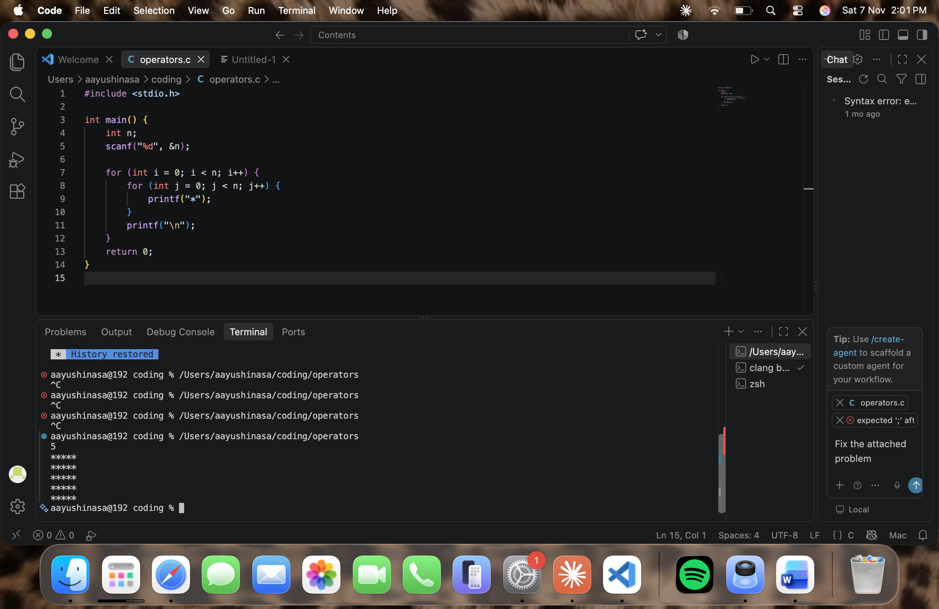

Question 32: Pattern: Right-Angled Triangle of Stars
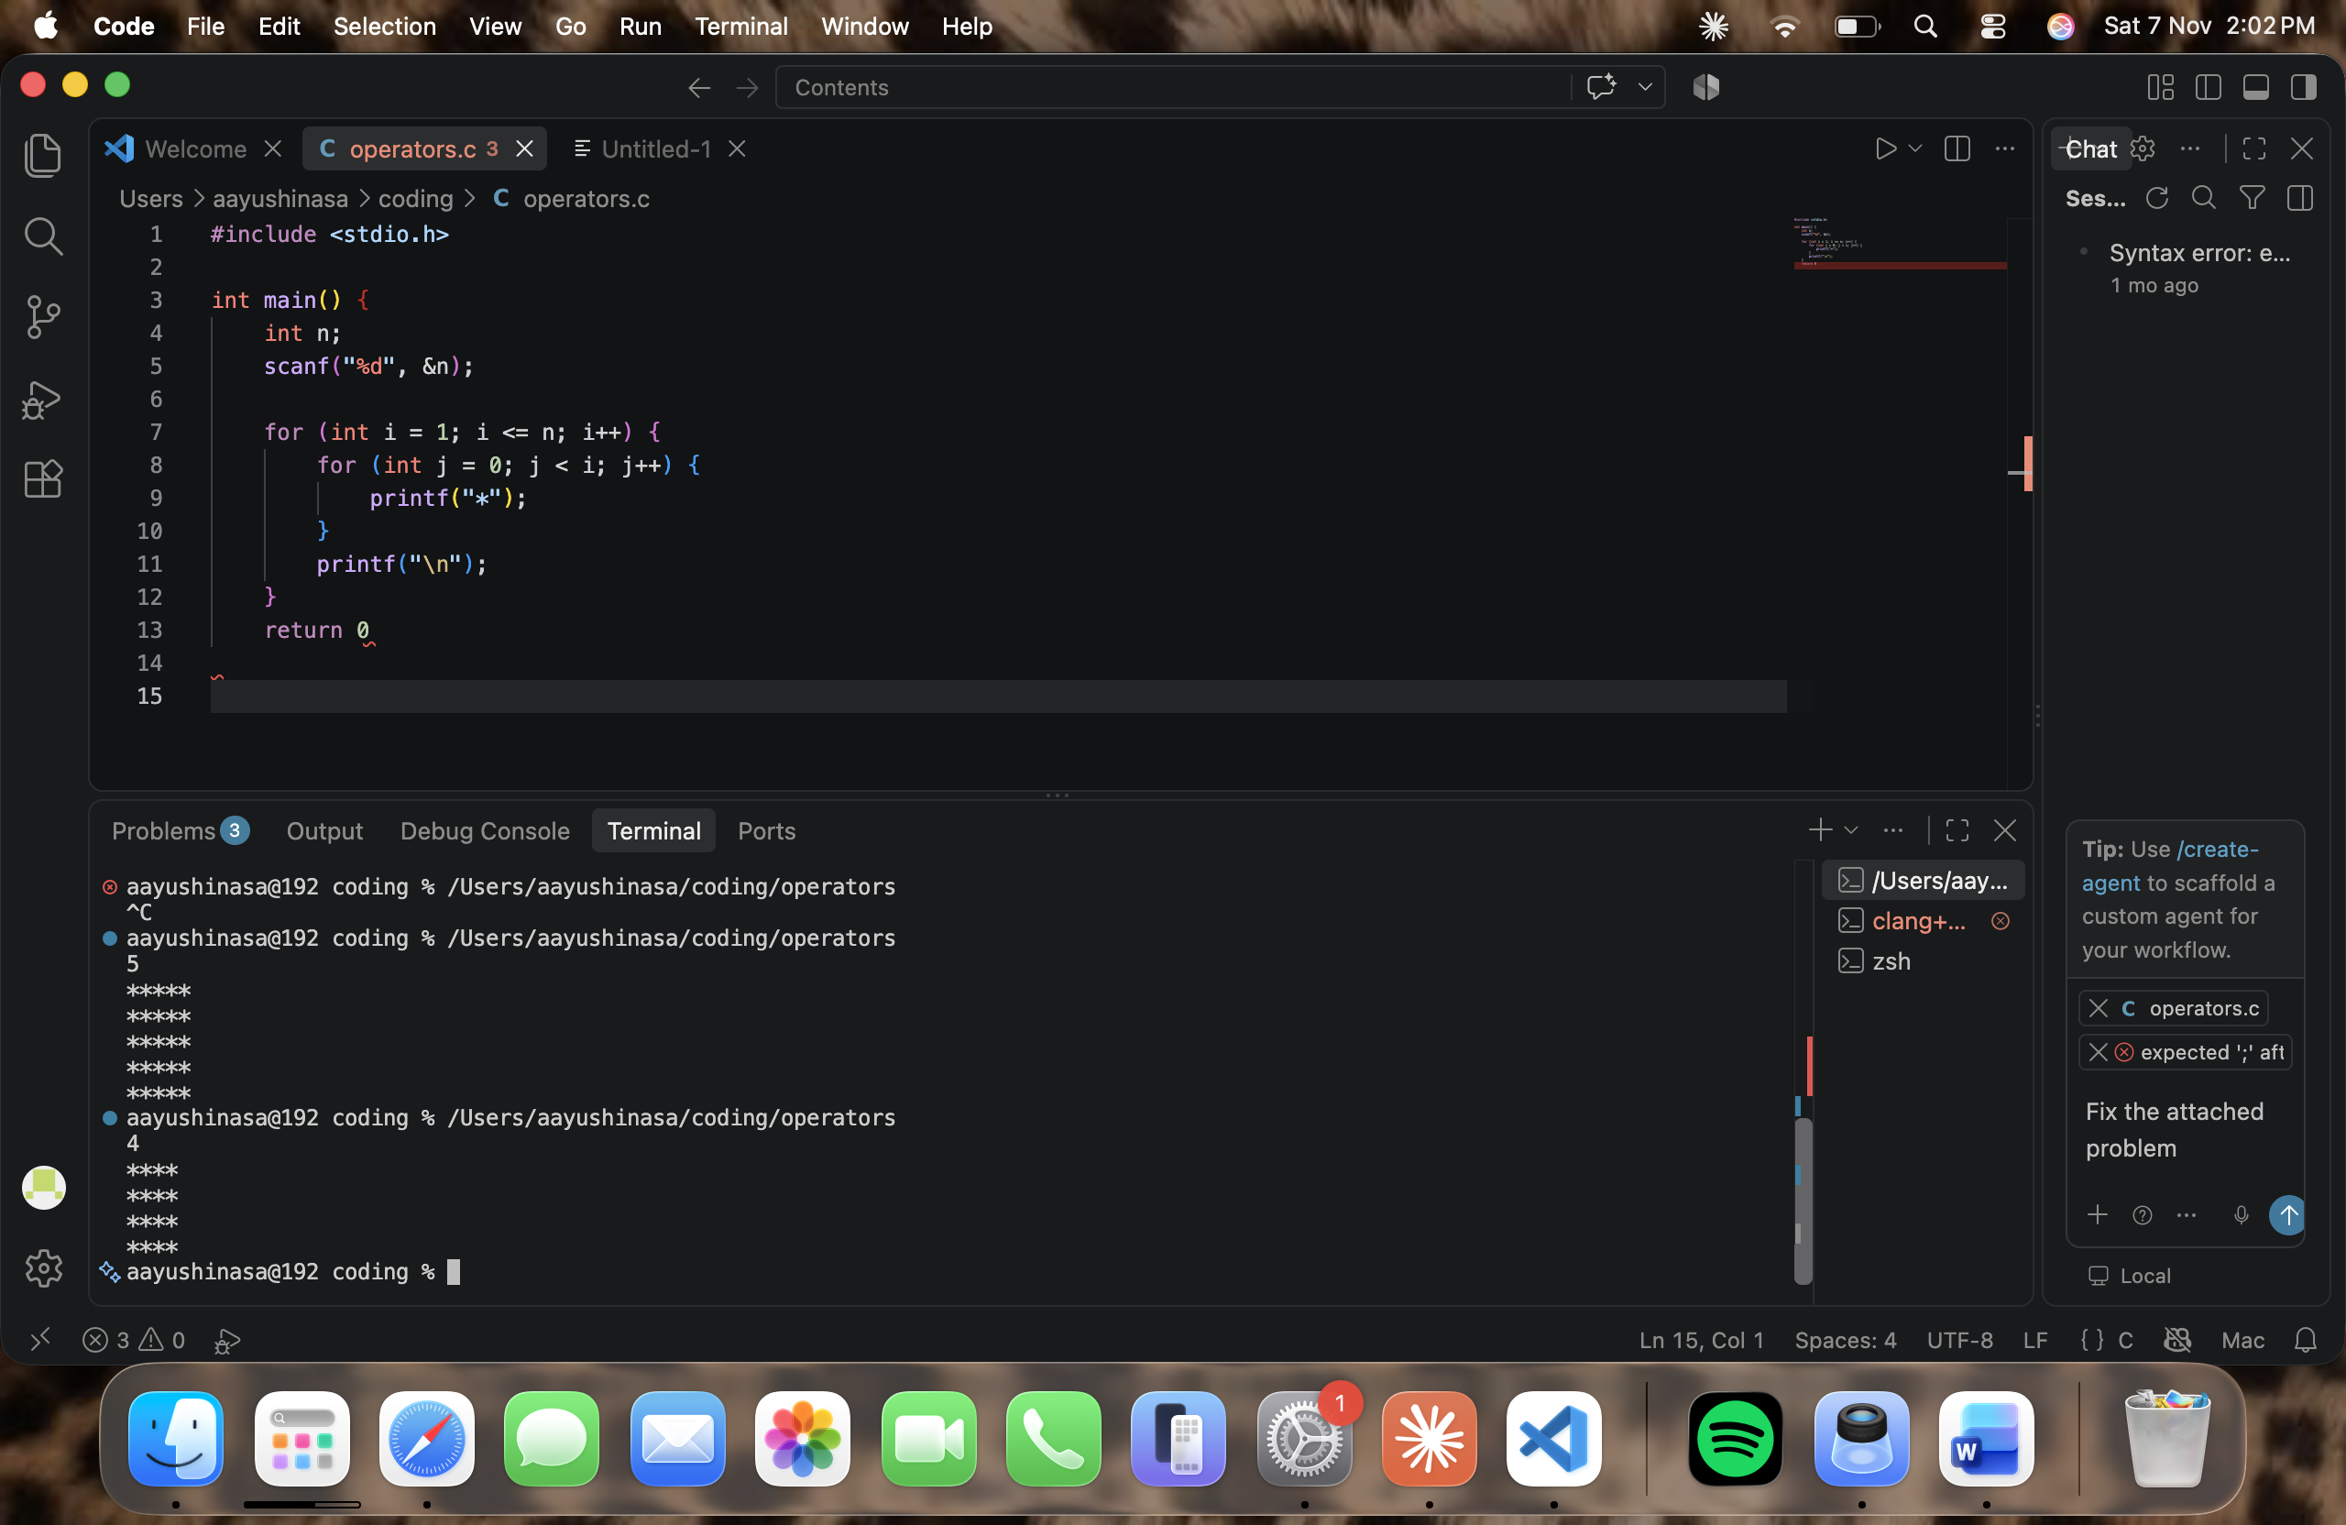

Question 33: Pattern: Inverted Right-Angled Triangle of Stars
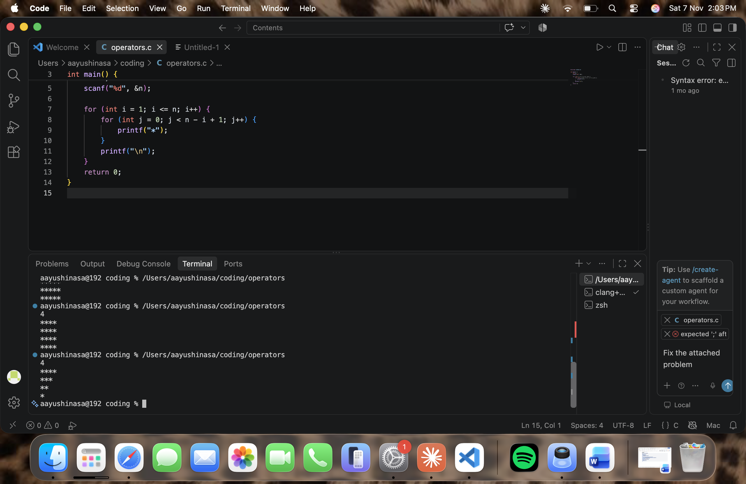

Question 34: Pattern: Number Triangle (1 2 3 ...)
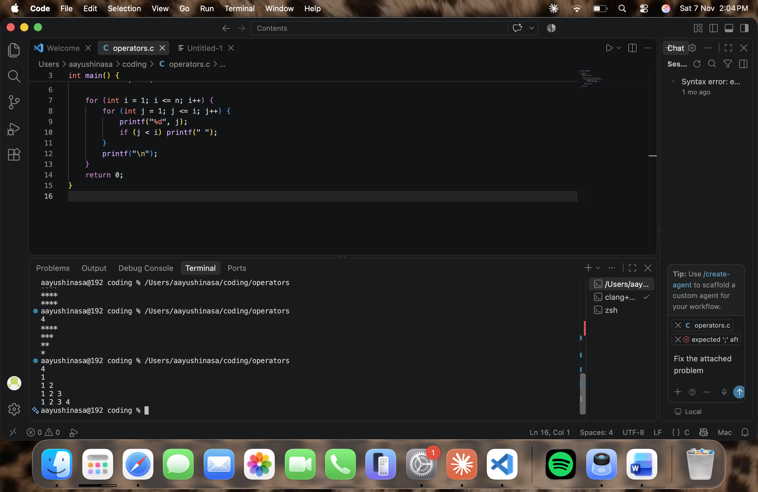

Question 35: Pattern: Row Number Triangle (1, 2 2, 3 3 3 ...)
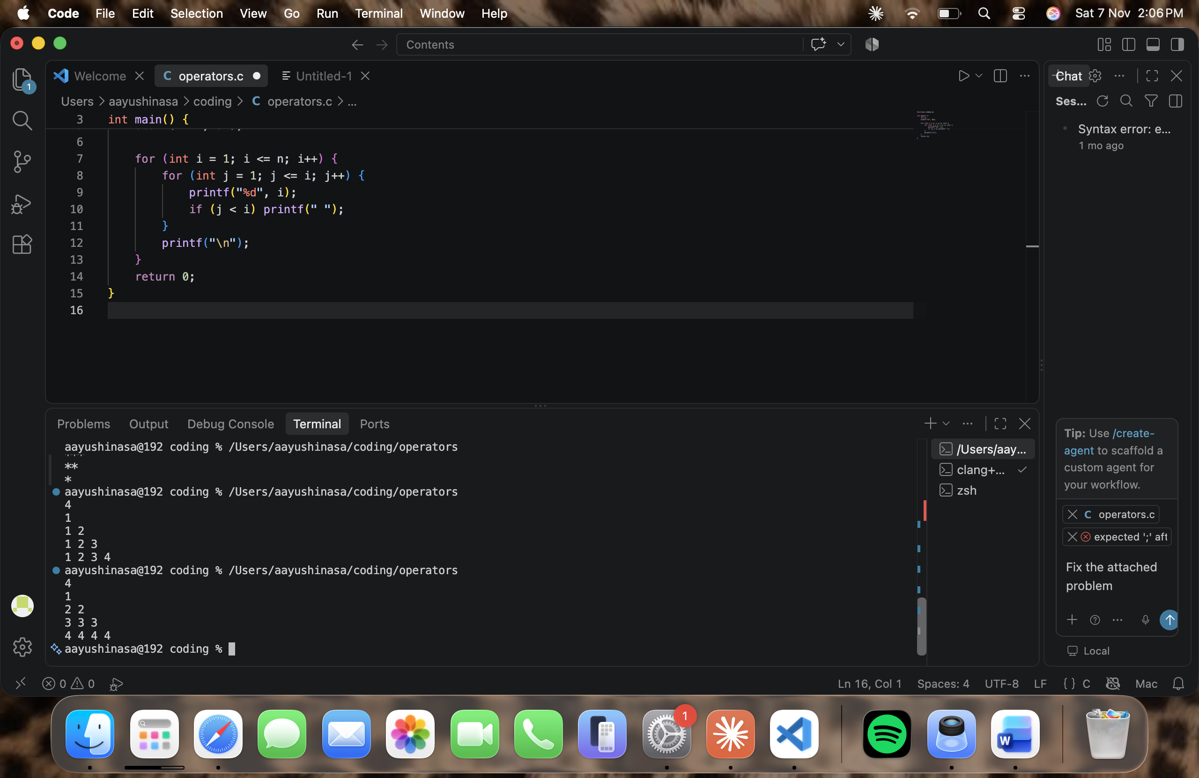
Question 36: Pattern: Floyd's Triangle
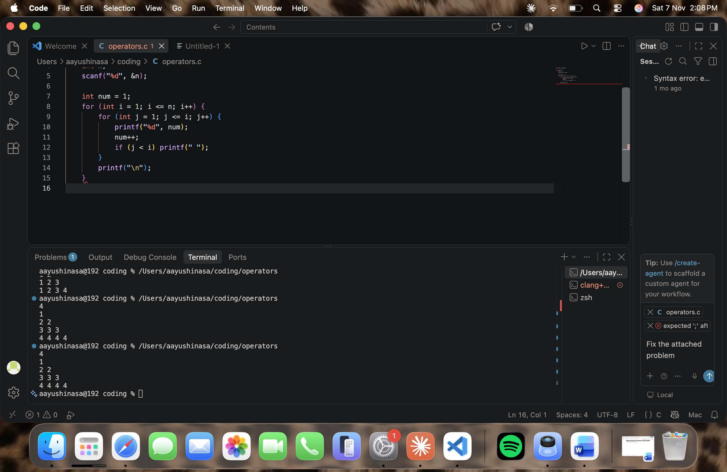

Question 37: Pattern: Right-Aligned Triangle of Stars
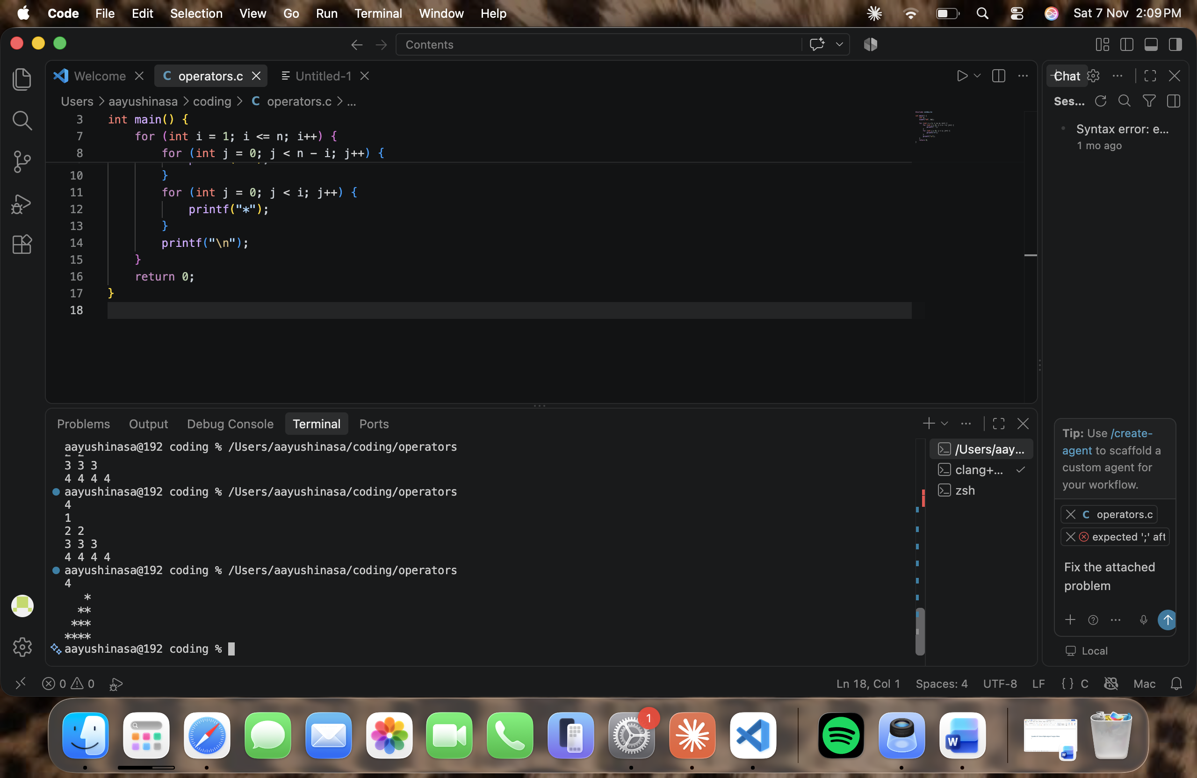

Question 38: Pattern: Pyramid of Stars
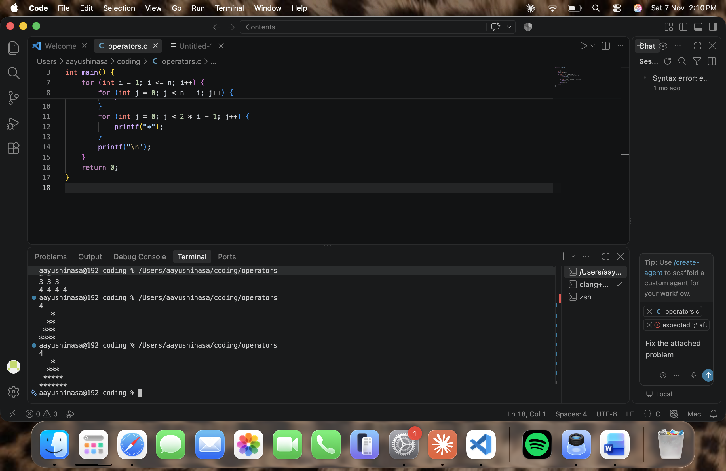

Question 39: Pattern: Inverted Pyramid of Stars
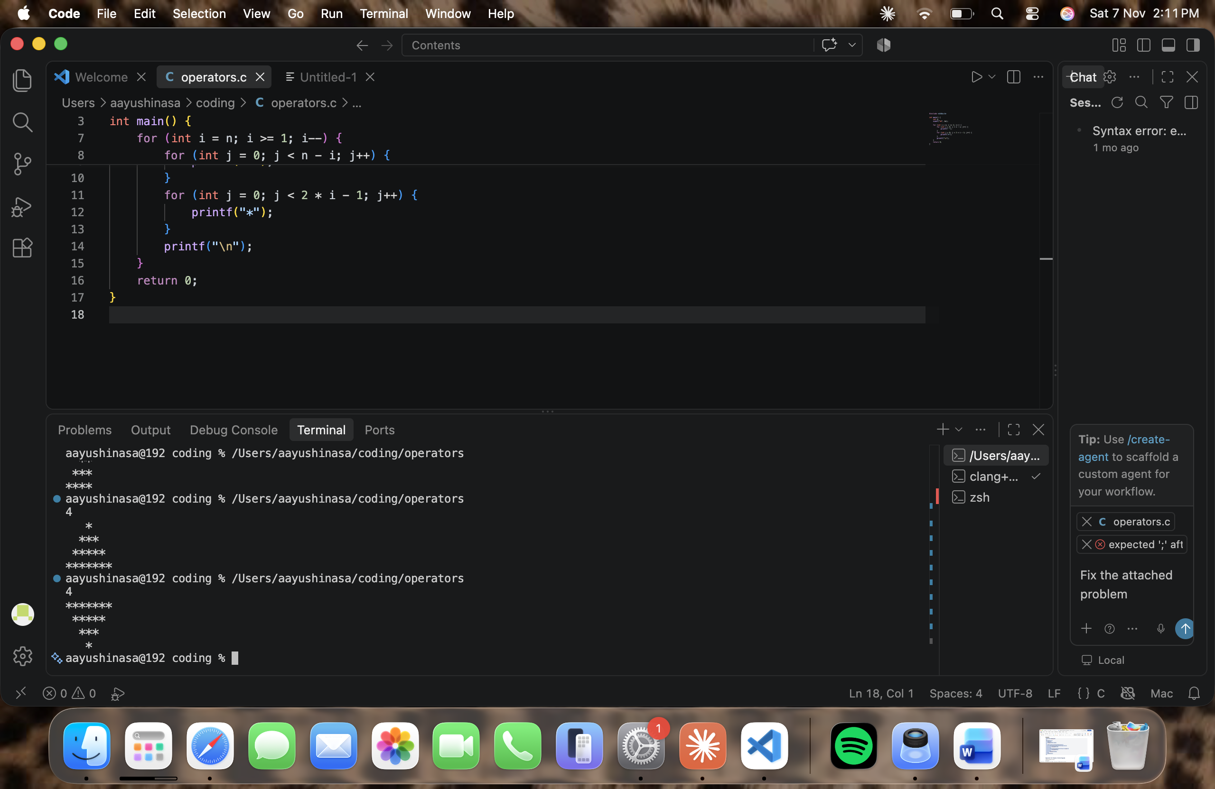

Question 40: Pattern: Hollow Square
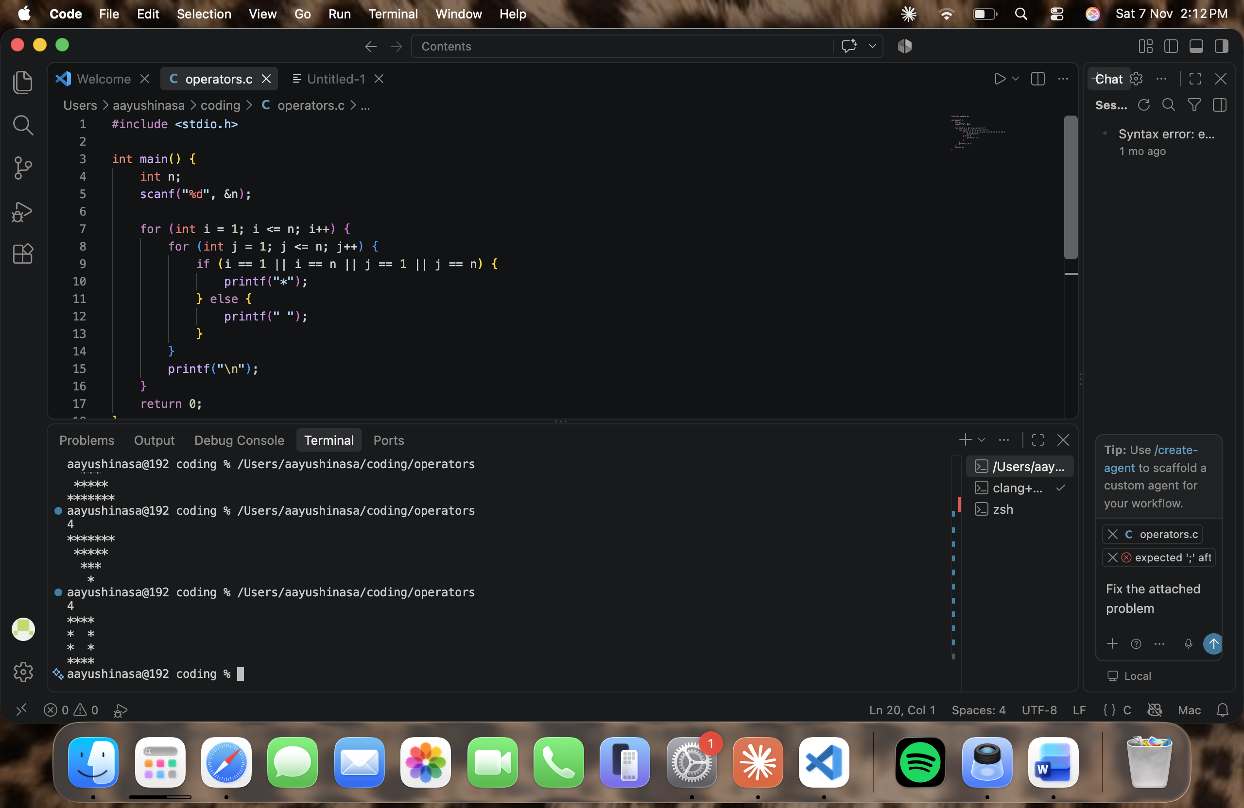

Question 41: Pattern: Hollow Right-Angled Triangle

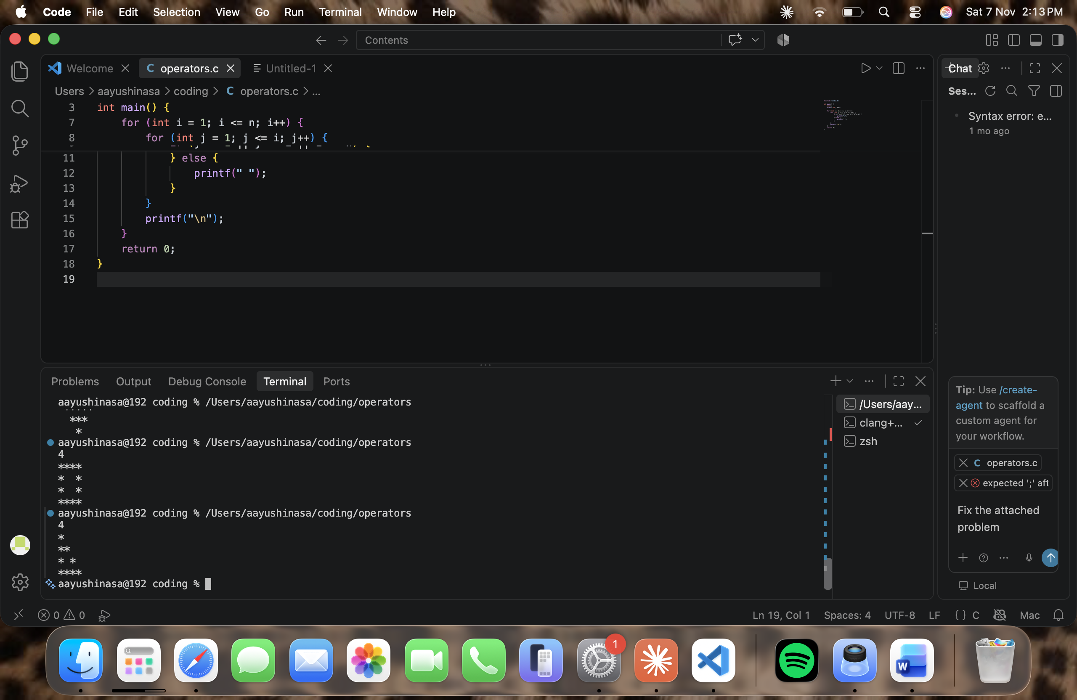

Question 42: Pattern: Multiplication Table
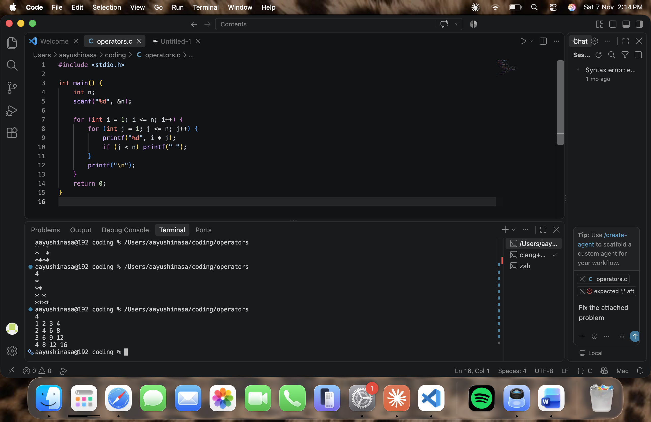

Question 43: Pattern: Checkerboard (X and O)
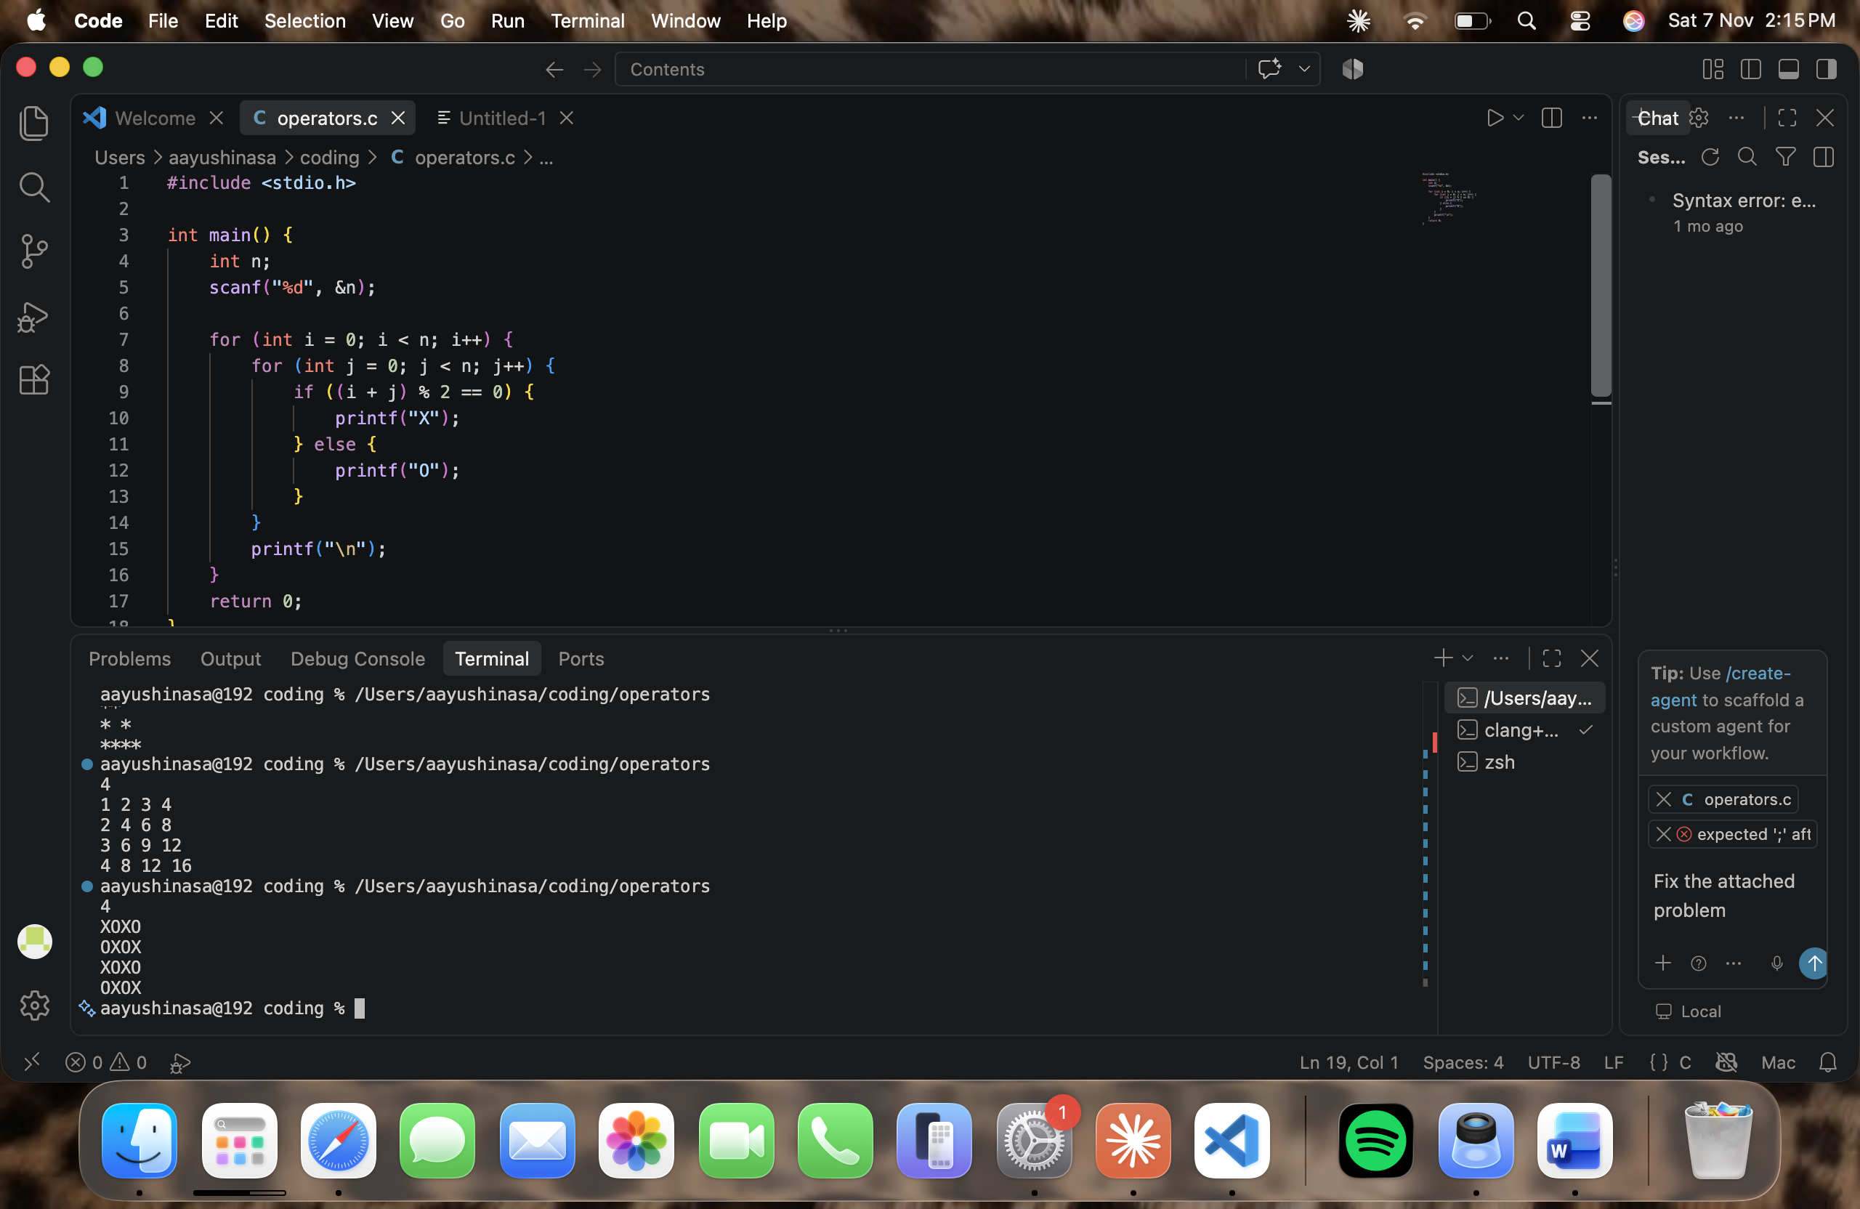

Question 44: Pattern: Floyd's Triangle (variant)
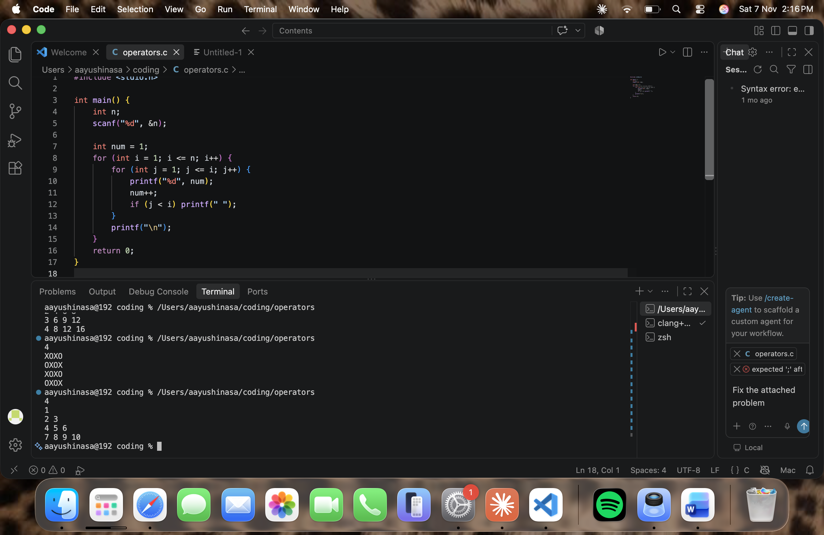

Question 46: Pattern: Butterfly


